**INTCDE21ID008**

**STAGE-3**

**916398 – SAAHIL TOMAR**

**Day 69 –** Angular

SESSION - 1

Hands-On:

Hello World in angular

app.component.ts

import

{ Component }

from '@angular/core';

@Component({

// selector: 'app-root',

// templateUrl: './app.component.html',

// styleUrls: ['./app.component.css']

selector: 'app-root',

template: `

< h2 > Hello World </ h2 >

`,

})

export class AppComponent

{

}

app.component.html

< hello - world ></ hello - world >

app.modules.ts

import

{ NgModule }

from '@angular/core';

import

{ BrowserModule }

from '@angular/platform-browser';

import

{ AppRoutingModule }

from './app-routing.module';

import

{ AppComponent }

from './app.component';

@NgModule({

declarations:[

AppComponent

],

imports:[

BrowserModule,

AppRoutingModule

],

providers:[],

bootstrap:[AppComponent]

})

export class AppModule { }

**OUTPUT**

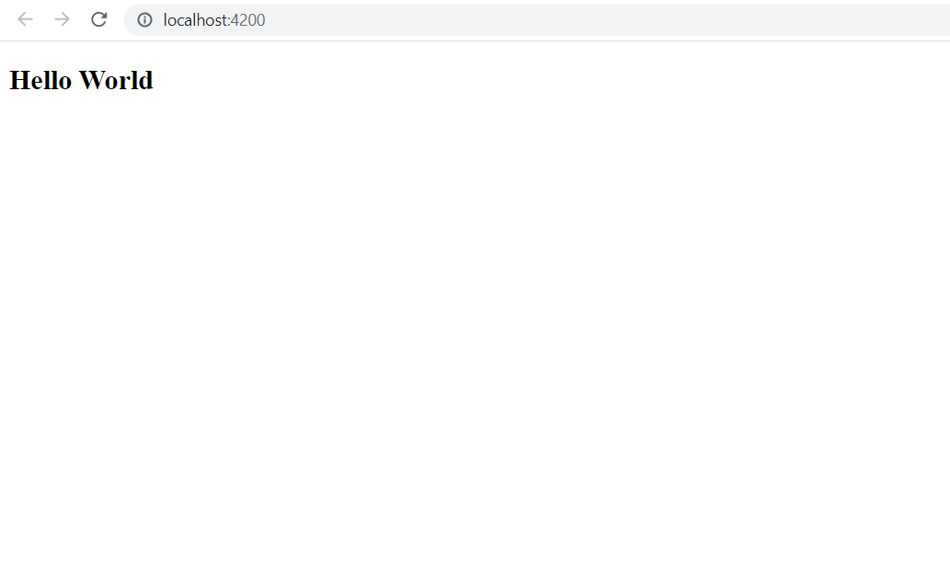

Display favorite movie

app.component.ts

import

{ Component }

from '@angular/core';

@Component({

selector: 'app-root',

// templateUrl: './app.component.html',

styleUrls:['./app.component.css'],

template: `

< span >{ { title } } </ span >

< h1[textContent] = "favoritemovie" ></ h1 >

`,

})

export class AppComponent

{

title = 'Favorite Movie:';

favoritemovie='Lord of the Rings';

}

app.component.spects.ts

import

{ DebugElement }

from '@angular/core';

import

{ TestBed }

from '@angular/core/testing';

import

{ RouterTestingModule }

from '@angular/router/testing';

import

{ AppComponent }

from './app.component';

describe('AppComponent', () => {

beforeEach(async () => {

await TestBed.configureTestingModule({

imports:[

RouterTestingModule

],

declarations:[

AppComponent

],

}).compileComponents();

});

it('should create the app', () => {

const fixture = TestBed.createComponent(AppComponent);

const app = fixture.componentInstance;

expect(app).toBeTruthy();

});

it(`should have as title 'Favorite Movie:'`, () => {

const fixture = TestBed.createComponent(AppComponent);

const app = fixture.componentInstance;

expect(app.title).toEqual('Favorite Movie:');

});

it('should render movie name in a h1 tag', () => { //6

const fixture = TestBed.createComponent(AppComponent);

fixture.detectChanges();

const compiled = fixture.debugElement.nativeElement;

expect(compiled.querySelector('h1').textContent).toEqual('Lord of the Rings');

});

});

**OUTPUT**

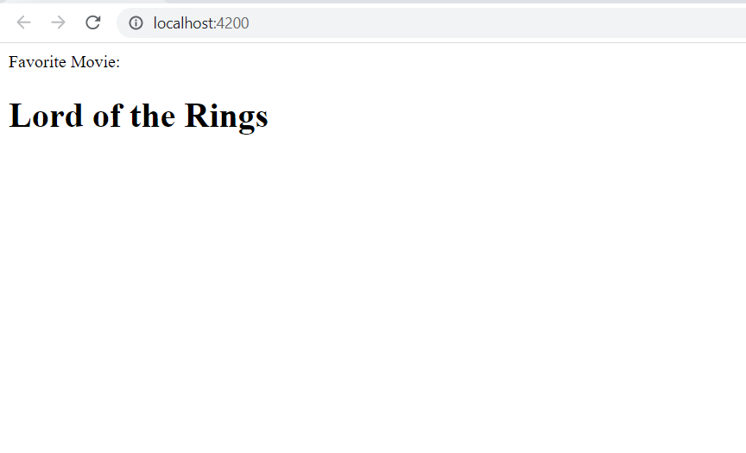

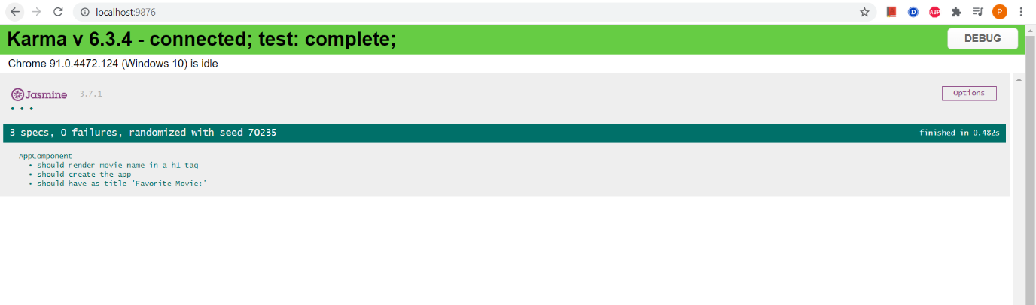

**Display Employee details**

app.component.ts

import

{ Component }

from '@angular/core';

import

{ Employee }

from './interface-component';

@Component({

selector: 'app-root',

templateUrl: './app.component.html',

styleUrls:['./app.component.css'],

})

export class AppComponent

{

title = 'Favorite Movie:';

heading='Employee Details';

ID=3;

Name='John';

Salary=10000;

}

interface-component.ts

export interface Employee

{

ID:number;

Name:string;

Salary:number;

}

app.component.html

< h3 >{ { heading} }</ h3 >

< p >< strong > ID:</ strong >{ { ID} }</ p >

< p >< strong > Name:</ strong >{ { Name} }</ p >

< p >< strong > Salary:</ strong >{ { Salary} }</ p >

**OUTPUT**

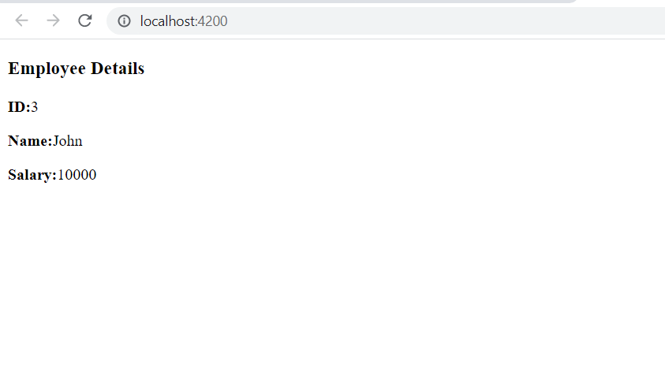

Display employee permanent details using ngIf

app.component.ts

import

{ Component }

from '@angular/core';

import

{ Employee }

from './interface-component';

@Component({

selector: 'app-root',

templateUrl: './app.component.html',

styleUrls:['./app.component.css'],

// template: `

// <span>{{ title }} </span>

// <h1 [textContent]="favoritemovie"></h1>

// `,

})

export class AppComponent

{

title = 'Favorite Movie:';

heading='Employee Details';

condition=true;

ID=3;

Name='John';

Salary=10000;

}

app.component.html

< !-- < span >{ { title } }

app is running!</ span > -->

< div >

< h3 >{ { heading} }</ h3 >

< p >< strong > ID:</ strong >{ { ID} }</ p >

< p >< strong > Name:</ strong >{ { Name} }</ p >

< p >< strong > Salary:</ strong >{ { Salary} }</ p >

< p * ngIf = "condition" >

< strong > Permenant </ strong > Yes

</ p >

</ div >

**OUTPUT**

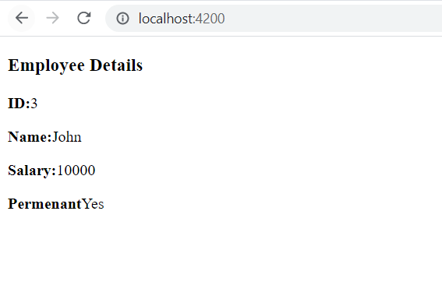

Display employee department details

Interface-component.ts

export interface Employee

{

ID:number;

Name:string;

Salary:number;

}

export interface Department

{

ID:number;

Name:string;

Salary:number;

Permenant:boolean;

Departmentid:number;

Departmentname:string;

}

export class Employee implements Department

{

ID: number;

Name: string;

Salary: number;

Permenant: boolean;

Departmentid: number;

Departmentname: string;

constructor(id:number, name:string, salary:number, permanent:boolean,deptid:number,deptname:string){

this.ID = id;

this.Name = name;

this.Salary = salary;

this.Permenant = permanent;

this.Departmentid = deptid;

this.Departmentname = deptname;

}

}

app.component.ts

import

{ Component }

from '@angular/core';

import

{ Employee }

from './interface-component';

@Component({

selector: 'app-root',

templateUrl: './app.component.html',

styleUrls:['./app.component.css'],

})

export class AppComponent

{

title = 'Favorite Movie:';

// heading='Employee Details';

emp1 = new Employee(3, "John", 10000, true,1,"Payroll");

}

app**.**component**.**html

< !-- < span >{ { title } }

app is running!</ span > -->

< div >

< p >< strong > ID:</ strong >{ { ID} }</ p >

< p >< strong > Name:</ strong >{ { Name} }</ p >

< p >< strong > Salary:</ strong >{ { Salary} }</ p >

< p >< strong > Permenant:</ strong >{ { Permenant} }</ p >

< p >< strong > Department Id:</ strong >{ { Departmentid} }</ p >

< p >< strong > Department Name:</ strong >{ { Departmentname} }</ p >

</ div >

**Output:**

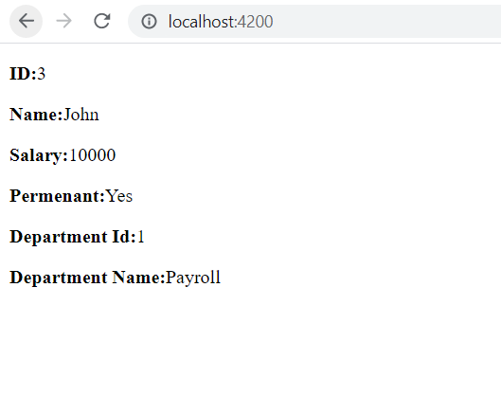

DisplayemployeeskilldetailsusingngFor

app**.**component**.**ts

import

{ Component }

from '@angular/core';

import

{ Employee}

from './interface-component';

@Component({

selector: 'app-root',

templateUrl: './app.component.html',

styleUrls:['./app.component.css'],

})

export class AppComponent

{

title = 'Favorite Movie:';

// heading='Employee Details';

emp1 = new Employee(3, "John", 10000, true,1,"Payroll");

public Skills:string[]=["Html","Css","JavaScripts"];

}

app**.**component**.**html

< !-- < span >{ { title } }

app is running!</ span > -->

< div >

< p >< strong > ID:</ strong >{ { emp1.ID} }</ p >

< p >< strong > Name:</ strong >{ { emp1.Name} }</ p >

< p >< strong > Salary:</ strong >{ { emp1.Salary} }</ p >

< p >< strong > Permenant:</ strong >{ { emp1.Permenant} }</ p >

< p >< strong > Department Id:</ strong >{ { emp1.Departmentid} }</ p >

< p >< strong > Department Name:</ strong >{ { emp1.Departmentname} }</ p >

< span >< strong > Skill Id Skill Name</strong></span>

<ol type="1">

<li *ngFor="let item of Skills">{{item}}</ li >

</ ol >

</ div >

**OUTPUT**

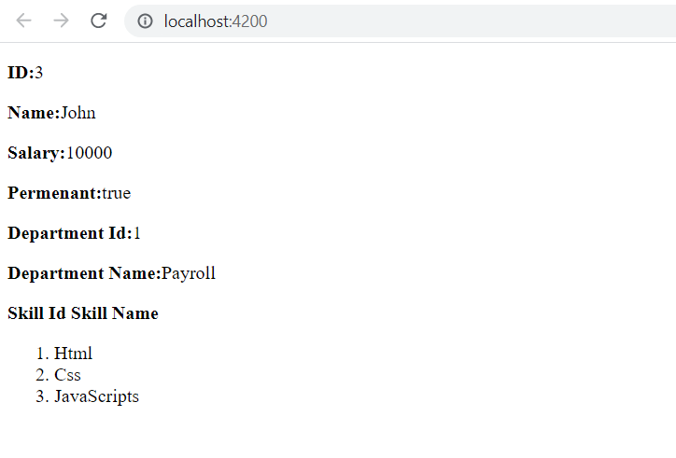

Displayemployeedetailswithdateofbirth

appcomponent**.**ts

import

{ Component }

from '@angular/core';

import

{ Employee}

from './interface-component';

@Component({

selector: 'app-root',

templateUrl: './app.component.html',

styleUrls:['./app.component.css'],

})

export class AppComponent

{

title = 'Favorite Movie:';

// heading='Employee Details';

emp1 = new Employee(3, "John", 10000, true,1,"Payroll");

Skills:string[]=["Html","Css","JavaScripts"];

DateofBirth:Date=new Date('12/31/2000');

}

app**.**component**.**html

< !-- < span >{ { title } }

app is running!</ span > -->

< div >

< p >< strong > ID:</ strong >{ { emp1.ID} }</ p >

< p >< strong > Name:</ strong >{ { emp1.Name} }</ p >

< p >< strong > Salary:</ strong >{ { emp1.Salary} }</ p >

< p >< strong > Permenant:</ strong >{ { emp1.Permenant} }</ p >

< p >< strong > Department Id:</ strong >{ { emp1.Departmentid} }</ p >

< p >< strong > Department Name:</ strong >{ { emp1.Departmentname} }</ p >

< span >< strong > Skill Id Skill Name</strong></span>

<ol type="1">

<li *ngFor="let item of Skills">{{item}}</ li >

</ ol >

< strong > Date Of Birth: </ strong >{ { DateofBirth} }

</ div >

**OUTPUT**

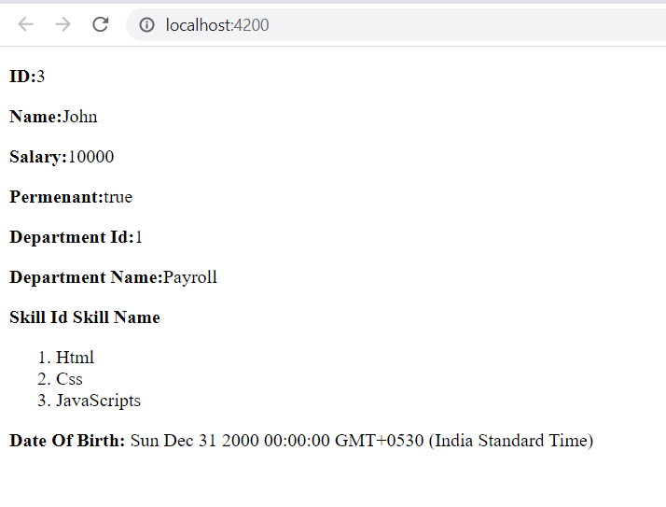

Displayemployeedateofbirthandsalaryincustomformat

app**.**component**.**ts

import

{ Component }

from '@angular/core';

import

{ Employee,Department}

from './interface-component';

@Component({

selector: 'app-root',

templateUrl: './app.component.html',

styleUrls:['./app.component.css'],

})

export class AppComponent

{

title = 'Favorite Movie:';

// heading='Employee Details';

public emp1 = new Employee(3, "John", 10000, true,1,"Payroll");

Permanent:boolean=true;

Skills:string[]=["Html","Css","JavaScripts"];

DateofBirth:Date=new Date('12/31/2000');

}

app.component.html

< !-- < span >{ { title } }

app is running!</ span > -->

< div >

< p >< strong > ID:</ strong >{ { emp1.ID} }</ p >

< p >< strong > Name:</ strong >{ { emp1.Name} }</ p >

< p >< strong > Salary:</ strong >{ { emp1.Salary} }</ p >

< p >< strong > Permenant:</ strong >{ { emp1.Permenant} }</ p >

< p >< strong > Department Id:</ strong >{ { emp1.Departmentid} }</ p >

< p >< strong > Department Name:</ strong >{ { emp1.Departmentname} }</ p >

< span >< strong > Skill Id Skill Name</strong></span>

<ol type="1">

<li *ngFor="let item of Skills">{{item}}</ li >

</ ol >

< strong > Date Of Birth: </ strong >{ { DateofBirth} }

</ div >

< div >

< h1 > Using Pipes </ h1 >

< strong > Id: </ strong >{ { emp1.ID} }< br >< br >

< strong > Name: </ strong >{ { emp1.Name} }< br >< br >

< strong > Salary: </ strong >{ { emp1.Salary | currency:"INR"} }

< br >< br >

< span * ngIf = "Permanent" >< strong > Permanent:</ strong > Yes </ span >

< br >< br >

< strong > Department Id: </ strong >{ { emp1.Departmentid} }

< br >< br >

< strong > Department Name: </ strong >{ { emp1.Departmentname} }

< br >< br >

< strong > Skills </ strong >

< br >< br >

< span >< strong > Skill Id Skill Name</strong></span>

<ol type="1">

<li *ngFor="let item of Skills">{{item}}</ li >

</ ol >

< strong > Date Of Birth:</ strong >{ { DateofBirth | date} }

</ div >

**OUTPUT**

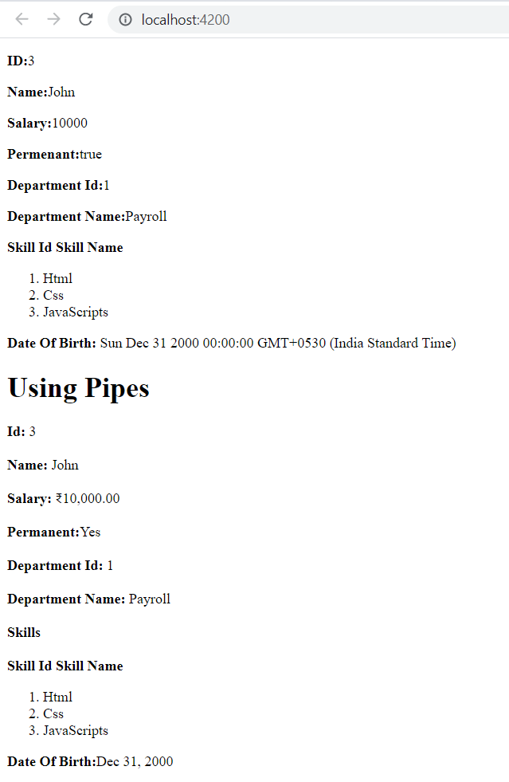

SESSION - 2

**Create View Employee Component**

**Display value based on button click**

**Event Handling and Two Way Binding - increment value in textbox based on button click**

app.module.ts

import

{ NgModule }

from '@angular/core';

import

{ BrowserModule }

from '@angular/platform-browser';

import

{ AppRoutingModule }

from './app-routing.module';

import

{ AppComponent }

from './app.component';

import

{ EditempComponent }

from './editemp/editemp.component';

import

{ QuantityIncrementComponent }

from './quantity-increment/quantity-increment.component';

import

{ ViewempsComponent }

from './viewemps/viewemps.component';

import

{ Routes,RouterModule}

from '@angular/router'

const appRoutes:Routes =[{ path: "" , component: ViewempsComponent},

{

path: "EditEmployees" ,

component: EditempComponent},{ path: "QuantityIncrement",component: QuantityIncrementComponent}]

@NgModule({

declarations:[

AppComponent,

ViewempsComponent,

EditempComponent,

QuantityIncrementComponent,

],

imports:[

BrowserModule,

AppRoutingModule,

RouterModule.forRoot(appRoutes)

],

providers:[],

bootstrap:[AppComponent]

})

export class AppModule { }

app.component.ts

import

{ Component }

from '@angular/core';

import

{ Employee,Department}

from './interface-component';

@Component({

selector: 'app-root',

templateUrl: './app.component.html',

styleUrls:['./app.component.css'],

})

export class AppComponent

{

}

App component.html

< style >

body {

font - family: Segoe UI, Arial

}

a

{ text - decoration: none }

</ style >

< h3 > Angular Learning<br> < a[routerLink] = "['/']" > View Employees </ a > ||< a[routerLink] = "['/EditEmployees']" > Edit Employees </ a >||

< a[routerLink] = "['QuantityIncrement']" > Quantity Increment </ a ></ h3 >

< div >

< router - outlet ></ router - outlet >

Quantity-increment.component.html

< p > Simple Button click Event!!</p>

<button (click)= "firstbutton()" > Click Me </ button >

< br >

< br >

{ { result} }

< br >

< input type = "text" value ={ { num} }>< button(click) = "Add()" > add </ button >

< br >

< br >

< input type = "submit" value = "sub"(click) = "sub1()"[disabled] = "flag" >< input type = "text" value ={ { addandsub} }>< input type = "submit" value = "add"(click) = "add1()" >

Quantity-increment.component.ts

import

{ Component, OnInit }

from '@angular/core';

@Component({

selector: 'app-quantity-increment',

templateUrl: './quantity-increment.component.html'

})

export class QuantityIncrementComponent

{

public result:string="";

public firstbutton() :void{

this.result="click me button clicked";

}

public num:number = 0;

public Add():void

{

this.num++;

}

public addandsub:number = 0;

public flag:boolean = true;

public add1():void

{

this.addandsub++;

if (this.addandsub > 0)

{

this.flag = false;

}

else

{

this.flag = true;

}

}

public sub1():void

{

this.addandsub--;

if (this.addandsub > 0)

{

this.flag = false;

}

else

{

this.flag = true;

}

}

}

Edit.component.ts

< p > editemp works! </ p >

Edit.component.ts

import

{ Component, OnInit }

from '@angular/core';

@Component({

selector: 'app-editemp',

templateUrl: './editemp.component.html'

})

export class EditempComponent implements OnInit

{

constructor() { }

ngOnInit(): void {

}

}

Viewemps.component.html

< strong > Id:</ strong >{ { Id} }< br >< br >

< strong > Name:</ strong >{ { Name} }< br >< br >

< strong > Salary:</ strong >{ { Salary | currency:"INR"} }

< br >< br >

< span * ngIf = "Permanent" >< strong > Permanent:</ strong > Yes </ span >

< br >< br >

< strong > Department Id:</ strong >{ { Department_Id} }

< br >< br >

< strong > Department Name:</ strong >{ { Department_Name} }

< br >< br >

< strong > Skills </ strong >

< br >< br >

< span >< strong > Skill Id Skill Name</strong></span>

<ol type="1">

<li *ngFor="let item of Skills">{{item}}</ li >

</ ol >

< br >

< br >

< strong > Date Of Birth:</ strong >{ { DateofBirth | date} }

Viewemps.component.ts

import

{ Component, OnInit }

from '@angular/core';

@Component({

selector: 'app-viewemps',

templateUrl: './viewemps.component.html'

})

export class ViewempsComponent

{

public Id:number=1;

public Name:string="John";

public Salary:number=10000;

public Permanent:boolean=true;

public Department_Id:number=1;

public Department_Name:string="payroll";

public Skills:string[]=["Html","Css","JavaScripts"];

public DateofBirth:Date=new Date('12/31/2000');

}

**OUTPUT**

